telecom_billing | SBP
V1.0

Revision History
Version | Date | Description | Author
1.0 | 17/02/2026 | Initial Version | Mohammed Megahed

Reviewers
# | Name | Position | Date and Signature
1
2

Acceptance and Signoff
# | Name | Position | Date and Signature
1
2

Contents
1. Introduction 5
1.1. Project Summary 5
1.2. In-Scope 5
1.3. Out-Scope 5
1.4. Target Audience 5
1.5. Abbreviations 5
1.6. Assumptions, Dependencies and Risks 5
1.7. Impact Questionnaire 6
2. Requirements Compliancy Matrix 6
3. Solution Architecture 7
3.1. Solution Description 7
3.2. Non-Functional Requirements 8
3.3. Security Considerations 8
4. Real-Time Usage Rating and Charging 9
4.1. Sequence Diagram 9
4.2. Flow Description 9
4.3. State Machine Diagram 12
4.4. APIs Contract Agreement 13
4.5. Error Handling 14
5. Monthly Invoice Generation 16
5.1. Sequence Diagram 16
5.2. Flow Description 17
5.3. State Machine Diagram 20
5.4. APIs Contract Agreement 22
5.5. Error Handling 22
6. Appendix 25
6.1. Real-Time Usage Rating and Charging Data Elements 25
6.2. Monthly Invoice Generation Data Elements 26
6.3. Solution Architecture Reference Documents 27

1. Introduction

1.1. Project Summary
We are building a convergent billing platform for telecommunications operators to manage customer accounts, subscriptions, and flexible product catalogs while supporting both prepaid and postpaid billing models. The system provides real-time usage rating and charging for voice, data, and SMS, generates postpaid invoices, and allows users to configure and track allowances. This enables operators to accurately bill customers and offer flexible pricing in a single solution.

1.2. In-Scope
# | Item
1. | Customer account and subscription management
2. | Product catalog with flexible pricing
3. | Real-time usage rating for voice, data, SMS
4. | Prepaid real-time charging
5. | Postpaid invoice generation
6. | Tax calculation and application
7. | Payment processing and collection

1.3. Out-Scope
# | Item
1. | Network provisioning and activation
2. | CRM and customer service
3. | Fraud management system
4. | Interconnect billing

1.4. Target Audience
# | Stakeholders
1. | Enterprise Architects
2. | Partners and Vendors Technical Leaders
3. | Infrastructure Architects & Engineers
4. | InfoSec Architects & Engineers
5. | Technical Managers
6. | Delivery Leads and Project Managers
7. | Developers

1.5. Abbreviations
# | Abbreviations | Full form
1

1.6. Assumptions, Dependencies and Risks
# | Item | Type | Owner | Comment
1.
2.

2. Requirements Compliancy Matrix
ID. | Title | Description | Compliancy | Comments
FR-1 | BillTel is a convergent billing platform for telecommunications operators | The platform enables telecommunications operators to manage and consolidate billing for multiple services in a single system, supporting streamlined operations and improved customer experience. | Compliant
FR-2 | The platform supports prepaid and postpaid billing, real-time charging, and invo | The platform enables customers to use both prepaid and postpaid billing options, provides real-time charging for services, and generates accurate invoices to support flexible payment and billing needs. | Compliant
FR-3 | Usage rating engine processes voice, data, and SMS with flexible tariff configur | The usage rating engine supports accurate calculation of charges for voice, data, and SMS services, allowing flexible adjustment of tariffs to meet business needs and customer offerings. | Compliant
FR-BR-001 | Account Management | Users can create, view, update, and deactivate their accounts to manage their personal information and preferences securely. | Compliant
FR-BR-002 | Product Catalog | The business maintains an up-to-date product catalog that provides accurate information about all available products and services. This ensures customers and stakeholders can easily access current product details, pricing, and availability. | Compliant
FR-BR-003 | Usage Rating | The system provides users with a clear rating of their usage to help them monitor and manage their consumption effectively. | Compliant
FR-BR-004 | Real-time Charging | The system calculates and applies charges instantly as transactions occur, ensuring customers have up-to-date account balances and accurate billing information at all times. | Compliant
FR-BR-005 | Allowances | The system enables users to manage and track employee allowances to ensure accurate compensation and compliance with company policies. | Compliant
FR-BR-006 | Invoice Generation | The system generates accurate invoices for all billable transactions to ensure customers receive clear and timely billing information. This supports transparent financial processes and enables efficient payment collection. | Compliant
FR-BR-007 | Tax Calculation | The system calculates and applies accurate tax amounts to transactions in accordance with current tax laws and regulations, ensuring compliance and correct billing for customers. | Compliant
FR-BR-008 | Payment Processing | The organization processes payments accurately and in a timely manner to ensure customers can complete transactions and receive confirmation of successful payment. | Compliant
FR-BR-009 | Dunning | The business must notify customers of overdue payments and provide clear information about outstanding balances and next steps to resolve them. This ensures timely collections and maintains transparency in customer communications. | Compliant
FR-BR-010 | Balance Notifications | Users receive timely notifications about changes to their account balance, helping them stay informed and manage their finances effectively. | Compliant

3. Solution Architecture

3.1. Solution Description
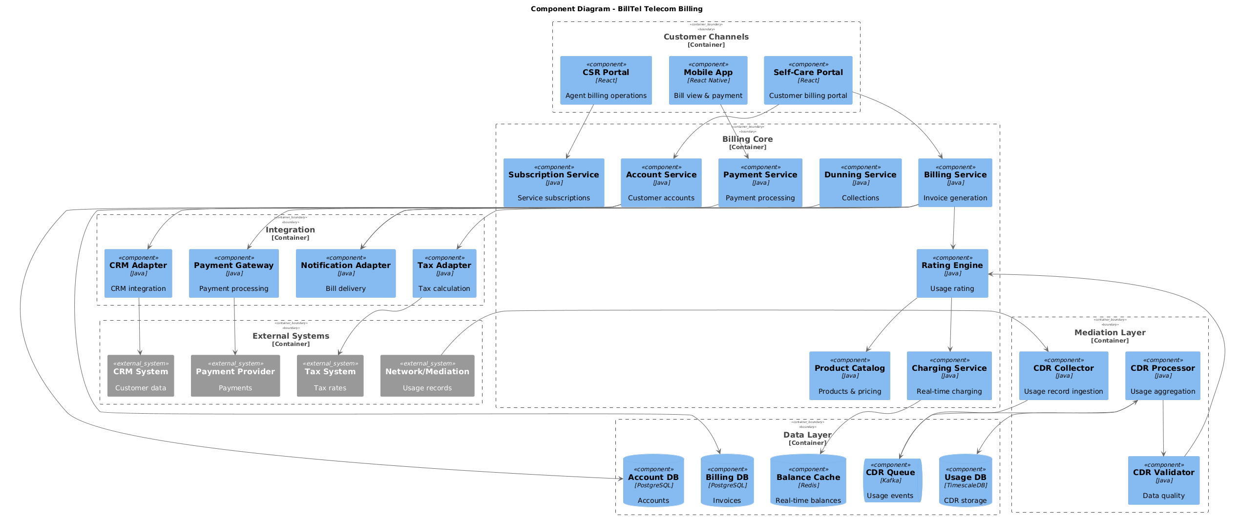

3.2. Non-Functional Requirements
# | Category | Requirement | Target/SLA
1 | Performance | API Response Time | < 2 seconds for 95th percentile
2 | Performance | Transaction Throughput | Support 100 TPS during peak hours
3 | Availability | System Uptime | 99.9% availability (excluding planned maintenance)
4 | Availability | Recovery Time Objective (RTO) | < 4 hours
5 | Availability | Recovery Point Objective (RPO) | < 1 hour
6 | Scalability | Horizontal Scaling | Support auto-scaling based on load
7 | Scalability | Concurrent Users | Support 1000 concurrent users
8 | Data Retention | Transaction Logs | Retain for 7 years as per regulatory requirements
9 | Data Retention | Audit Logs | Retain for 5 years
10 | Compliance | Regulatory | Comply with CMA and SAMA regulations
11 | Compliance | Data Protection | Comply with data privacy requirements

3.3. Security Considerations
# | Security Domain | Requirement | Implementation
1 | Authentication | User Authentication | OAuth 2.0 / JWT tokens with secure token storage
2 | Authentication | Service-to-Service Auth | Mutual TLS (mTLS) for internal service communication
3 | Authentication | Multi-Factor Authentication | MFA required for sensitive operations
4 | Authorization | Role-Based Access Control | RBAC implemented with principle of least privilege
5 | Authorization | API Authorization | Scope-based access control for API endpoints
6 | Data Protection | Data in Transit | TLS 1.2+ encryption for all network communication
7 | Data Protection | Data at Rest | AES-256 encryption for sensitive data storage
8 | Data Protection | PII/Sensitive Data | Data masking and tokenization for sensitive fields
9 | API Security | Input Validation | Server-side validation of all input parameters
10 | API Security | Rate Limiting | Rate limiting to prevent abuse and DDoS attacks
11 | API Security | CORS Policy | Strict CORS policy for web API endpoints
12 | Audit & Logging | Audit Trail | Log all security-relevant events with timestamps
13 | Audit & Logging | Log Protection | Immutable logs with tamper detection
14 | Vulnerability Management | Security Scanning | Regular SAST/DAST scanning in CI/CD pipeline
15 | Vulnerability Management | Dependency Scanning | Automated scanning for vulnerable dependencies

4. Real-Time Usage Rating and Charging

4.1. Sequence Diagram
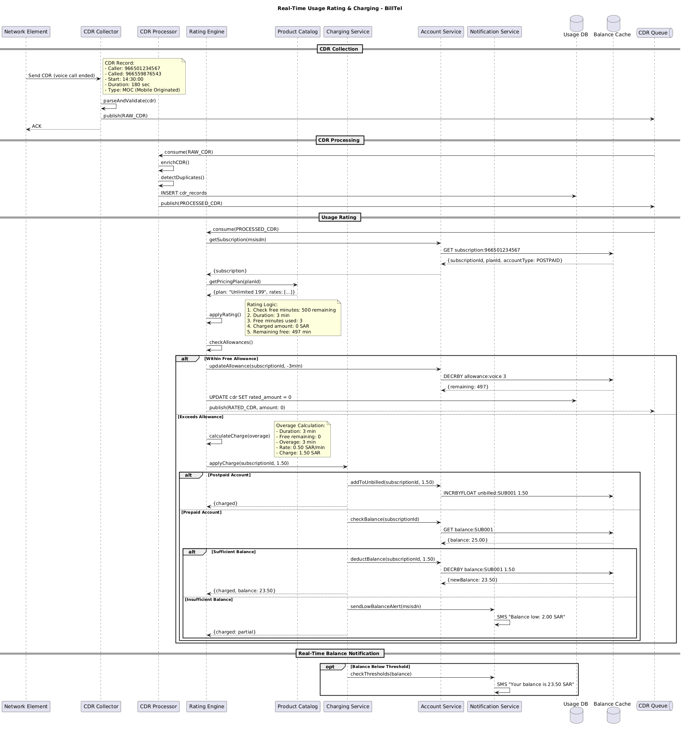

4.2. Flow Description
  - Overview
This flow describes the real-time usage rating and charging process for the BillTel platform. It covers the end-to-end lifecycle of a voice call event, starting from the generation of a Call Detail Record by the Network Element, through collection, processing, rating, charging, and notification. The flow involves the following active participants: Network Element, CDR Collector, CDR Processor, Rating Engine, Product Catalog, Charging Service, Account Service, Notification Service, Usage DB, Balance Cache, and CDR Queue. Each participant is responsible for specific processing, validation, enrichment, rating, charging, and notification tasks as the CDR moves through the system.
  - Process Flow
CDR Collection
The process begins when the Network Element sends a CDR representing a completed voice call to the CDR Collector.
Note: CDR Record:
- Caller: 966501234567
- Called: 966559876543
- Start: 14:30:00
- Duration: 180 sec
- Type: MOC (Mobile Originated)
CDR Collector internally parses and validates the received CDR. The CDR Collector then publishes the raw CDR to the CDR Queue for downstream processing. After publishing, the CDR Collector sends an acknowledgment back to the Network Element.
CDR Processing
The CDR Processor consumes the raw CDR from the CDR Queue. CDR Processor internally enriches the CDR with additional data as required. CDR Processor then internally detects any duplicate records to prevent double processing. After these internal operations, the CDR Processor inserts the processed CDR into the Usage DB. The CDR Processor also publishes the processed CDR to the CDR Queue for further handling.
Usage Rating
The Rating Engine consumes the processed CDR from the CDR Queue. To determine the appropriate rating, the Rating Engine requests the subscription details for the caller’s MSISDN from the Account Service. The Account Service retrieves the subscription information from the Balance Cache and returns the subscription ID, plan ID, and account type (for example, POSTPAID) to the Rating Engine.
Next, the Rating Engine requests the pricing plan details from the Product Catalog using the plan ID. The Product Catalog responds with the plan details and associated rates.
Rating Engine internally applies the rating logic to the CDR.
Note: Rating Logic:
1. Check free minutes: 500 remaining
2. Duration: 3 min
3. Free minutes used: 3
4. Charged amount: 0 SAR
5. Remaining free: 497 min
Rating Engine internally checks the subscriber’s allowances to determine if the usage falls within the free allowance or exceeds it.
If the usage is within the free allowance, the following steps occur:
• The Rating Engine instructs the Account Service to update the allowance for the subscription, deducting the used minutes.
• The Account Service decrements the voice allowance in the Balance Cache by the used amount.
• The Balance Cache returns the remaining allowance to the Account Service.
• The Rating Engine updates the rated amount for the CDR in the Usage DB to zero.
• The Rating Engine publishes a rated CDR with an amount of zero to the CDR Queue.
If the usage exceeds the free allowance, Rating Engine internally calculates the overage charge.
Note: Overage Calculation:
- Duration: 3 min
- Free remaining: 0
- Overage: 3 min
- Rate: 0.50 SAR/min
- Charge: 1.50 SAR
The Rating Engine then instructs the Charging Service to apply the calculated charge to the subscription.
If the account is postpaid:
• The Charging Service requests the Account Service to add the charge to the unbilled amount for the subscription.
• The Account Service increments the unbilled amount in the Balance Cache.
• The Charging Service confirms the charge to the Rating Engine.
If the account is prepaid:
• The Charging Service requests the Account Service to check the current balance for the subscription.
• The Account Service retrieves the balance from the Balance Cache and returns it.
If the balance is sufficient to cover the charge
• The Charging Service instructs the Account Service to deduct the charge amount from the balance.
• The Account Service decrements the balance in the Balance Cache.
• The Balance Cache returns the new balance to the Account Service.
• The Charging Service confirms the charge and provides the updated balance to the Rating Engine.
If the balance is insufficient
• The Charging Service sends a low balance alert to the Notification Service.
• Notification Service internally sends an SMS notification: "Balance low: 2.00 SAR".
• The Charging Service confirms a partial charge to the Rating Engine.
Real-Time Balance Notification
Optionally, if the balance falls below a defined threshold, the Charging Service checks the notification thresholds with the Notification Service. Notification Service internally sends an SMS notification: "Your balance is 23.50 SAR".
  - Authentication & Validation
• CDR Collector internally parses and validates incoming CDRs to ensure data integrity.
• CDR Processor internally enriches CDRs and detects duplicates to maintain accuracy and prevent double charging.
• Rating Engine internally applies rating logic and checks allowances to determine the correct charging path.
• Rating Engine internally calculates overage charges when usage exceeds allowances.
• Notification Service internally handles SMS notifications for low balance and threshold alerts.

4.3. State Machine Diagram
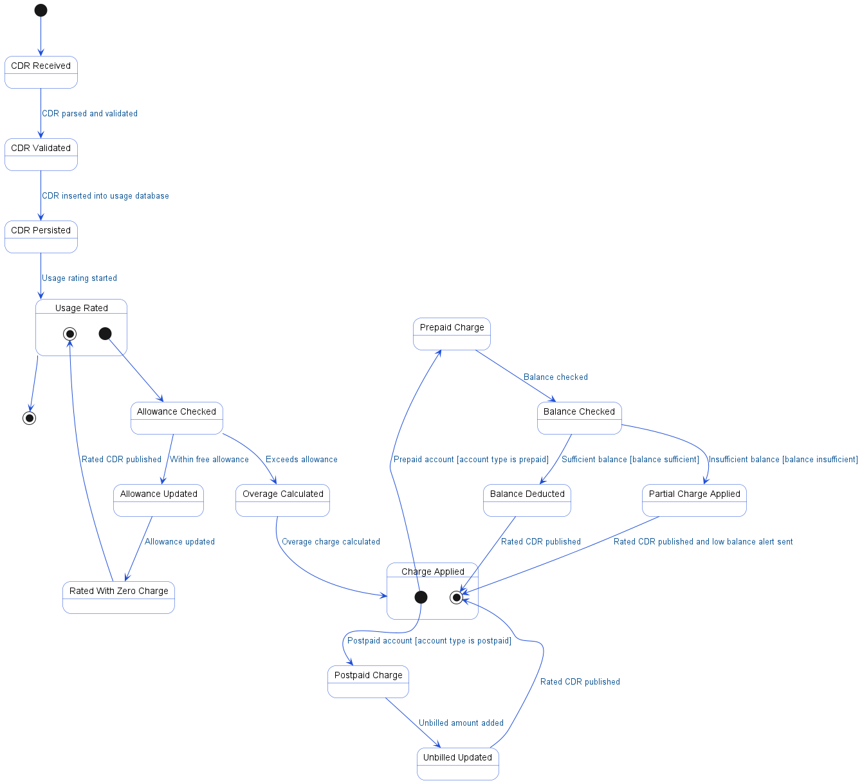

4.4. APIs Contract Agreement
# | Source | Destination | API | Protocol | Request Parameters | Response Parameters
1 | Network Element | CDR Collector | Send CDR | REST | voice call ended | ACK
2 | CDR Collector | CDR Queue | publish | REST | RAW_CDR
3 | CDR Queue | CDR Processor | consume | REST | RAW_CDR
4 | CDR Processor | Usage DB | INSERT cdr_records | JDBC
5 | CDR Processor | CDR Queue | publish | REST | PROCESSED_CDR
6 | CDR Queue | Rating Engine | consume | REST | PROCESSED_CDR | RATED_CDR, amount: 0
7 | Rating Engine | Account Service | getSubscription | REST | msisdn | {subscription}
8 | Account Service | Balance Cache | GET subscription:966501234567 | REST |  | {subscriptionId, planId, accountType: POSTPAID}
9 | Rating Engine | Product Catalog | getPricingPlan | REST | planId | {plan: "Unlimited 199", rates: [...]}
10 | Rating Engine | Account Service | updateAllowance | REST | subscriptionId, -3min
11 | Account Service | Balance Cache | DECRBY allowance:voice 3 | REST |  | {remaining: 497}
12 | Rating Engine | Usage DB | UPDATE cdr SET rated_amount = 0 | JDBC
13 | Rating Engine | Charging Service | applyCharge | REST | subscriptionId, 1.50 | {charged}
14 | Charging Service | Account Service | addToUnbilled | REST | subscriptionId, 1.50
15 | Account Service | Balance Cache | INCRBYFLOAT unbilled:SUB001 1.50 | REST |  | {balance: 25.00}
16 | Charging Service | Account Service | checkBalance | REST | subscriptionId
17 | Account Service | Balance Cache | GET balance:SUB001 | REST |  | {newBalance: 23.50}
18 | Charging Service | Account Service | deductBalance | REST | subscriptionId, 1.50
19 | Account Service | Balance Cache | DECRBY balance:SUB001 1.50 | REST
20 | Charging Service | Notification Service | sendLowBalanceAlert | REST | msisdn
21 | Charging Service | Notification Service | checkThresholds | REST | balance
[*] Indicates that the data element is optional

4.5. Error Handling
# | Source | Destination | Scenario | Handling
1 | CDR Collector | CDR Queue | publish  Timeout while publishing RAW_CDR to queue | Retry up to 3 times with exponential backoff; Log error with correlation ID for traceability; Queue request for asynchronous retry
2 | CDR Processor | Usage DB | INSERT  Usage DB unavailable during CDR record insertion | Retry up to 3 times with exponential backoff; Log error with correlation ID for traceability; Queue request for asynchronous retry
3 | CDR Processor | CDR Queue | publish  Timeout while publishing PROCESSED_CDR to queue | Retry up to 3 times with exponential backoff; Log error with correlation ID for traceability; Queue request for asynchronous retry
4 | Rating Engine | Account Service | getSubscription  Account Service unavailable during subscription retrieval | Retry up to 3 times with exponential backoff; Log error with correlation ID for traceability; Activate circuit breaker, use fallback response
5 | Rating Engine | Account Service | getSubscription  Subscription not found for given msisdn | Return error code to upstream caller; Log error with correlation ID for traceability
6 | Account Service | Balance Cache | GET  Timeout while retrieving subscription from Balance Cache | Retry up to 3 times with exponential backoff; Log error with correlation ID for traceability; Return error code to upstream caller
7 | Rating Engine | Product Catalog | getPricingPlan  Product Catalog unavailable during pricing plan retrieval | Retry up to 3 times with exponential backoff; Log error with correlation ID for traceability; Activate circuit breaker, use fallback response
8 | Rating Engine | Product Catalog | getPricingPlan  Pricing plan not found for given planId | Return error code to upstream caller; Log error with correlation ID for traceability
9 | Rating Engine | Account Service | updateAllowance  Timeout while updating allowance | Retry up to 3 times with exponential backoff; Log error with correlation ID for traceability; Queue request for asynchronous retry
10 | Account Service | Balance Cache | DECRBY  Balance Cache unavailable during allowance decrement | Retry up to 3 times with exponential backoff; Log error with correlation ID for traceability; Queue request for asynchronous retry
11 | Rating Engine | Usage DB | UPDATE  Usage DB unavailable during CDR update | Retry up to 3 times with exponential backoff; Log error with correlation ID for traceability; Queue request for asynchronous retry
12 | Rating Engine | CDR Queue | publish  Timeout while publishing RATED_CDR to queue | Retry up to 3 times with exponential backoff; Log error with correlation ID for traceability; Queue request for asynchronous retry
13 | Rating Engine | Charging Service | applyCharge  Timeout while applying charge to subscription | Ensure idempotency to avoid duplicates on retry; Retry up to 3 times with exponential backoff; Log error with correlation ID for traceability; Queue request for asynchronous retry
14 | Charging Service | Account Service | addToUnbilled  Timeout while adding charge to unbilled amount | Ensure idempotency to avoid duplicates on retry; Retry up to 3 times with exponential backoff; Log error with correlation ID for traceability; Queue request for asynchronous retry
15 | Account Service | Balance Cache | INCRBYFLOAT  Balance Cache unavailable during unbilled increment | Retry up to 3 times with exponential backoff; Log error with correlation ID for traceability; Queue request for asynchronous retry
16 | Charging Service | Account Service | checkBalance  Account Service unavailable during balance check | Retry up to 3 times with exponential backoff; Log error with correlation ID for traceability; Activate circuit breaker, use fallback response
17 | Account Service | Balance Cache | GET  Timeout while retrieving balance from Balance Cache | Retry up to 3 times with exponential backoff; Log error with correlation ID for traceability; Return error code to upstream caller
18 | Charging Service | Account Service | deductBalance  Timeout while deducting balance | Ensure idempotency to avoid duplicates on retry; Retry up to 3 times with exponential backoff; Log error with correlation ID for traceability; Queue request for asynchronous retry
19 | Account Service | Balance Cache | DECRBY  Balance Cache unavailable during balance deduction | Retry up to 3 times with exponential backoff; Log error with correlation ID for traceability; Queue request for asynchronous retry
20 | Charging Service | Notification Service | sendLowBalanceAlert  Notification Service unavailable during low balance alert | Ensure idempotency to avoid duplicates on retry; Retry up to 3 times with exponential backoff; Log error with correlation ID for traceability; Queue request for asynchronous retry
21 | Charging Service | Notification Service | checkThresholds  Timeout while checking balance thresholds | Retry up to 3 times with exponential backoff; Log error with correlation ID for traceability; Return error code to upstream caller

5. Monthly Invoice Generation

5.1. Sequence Diagram
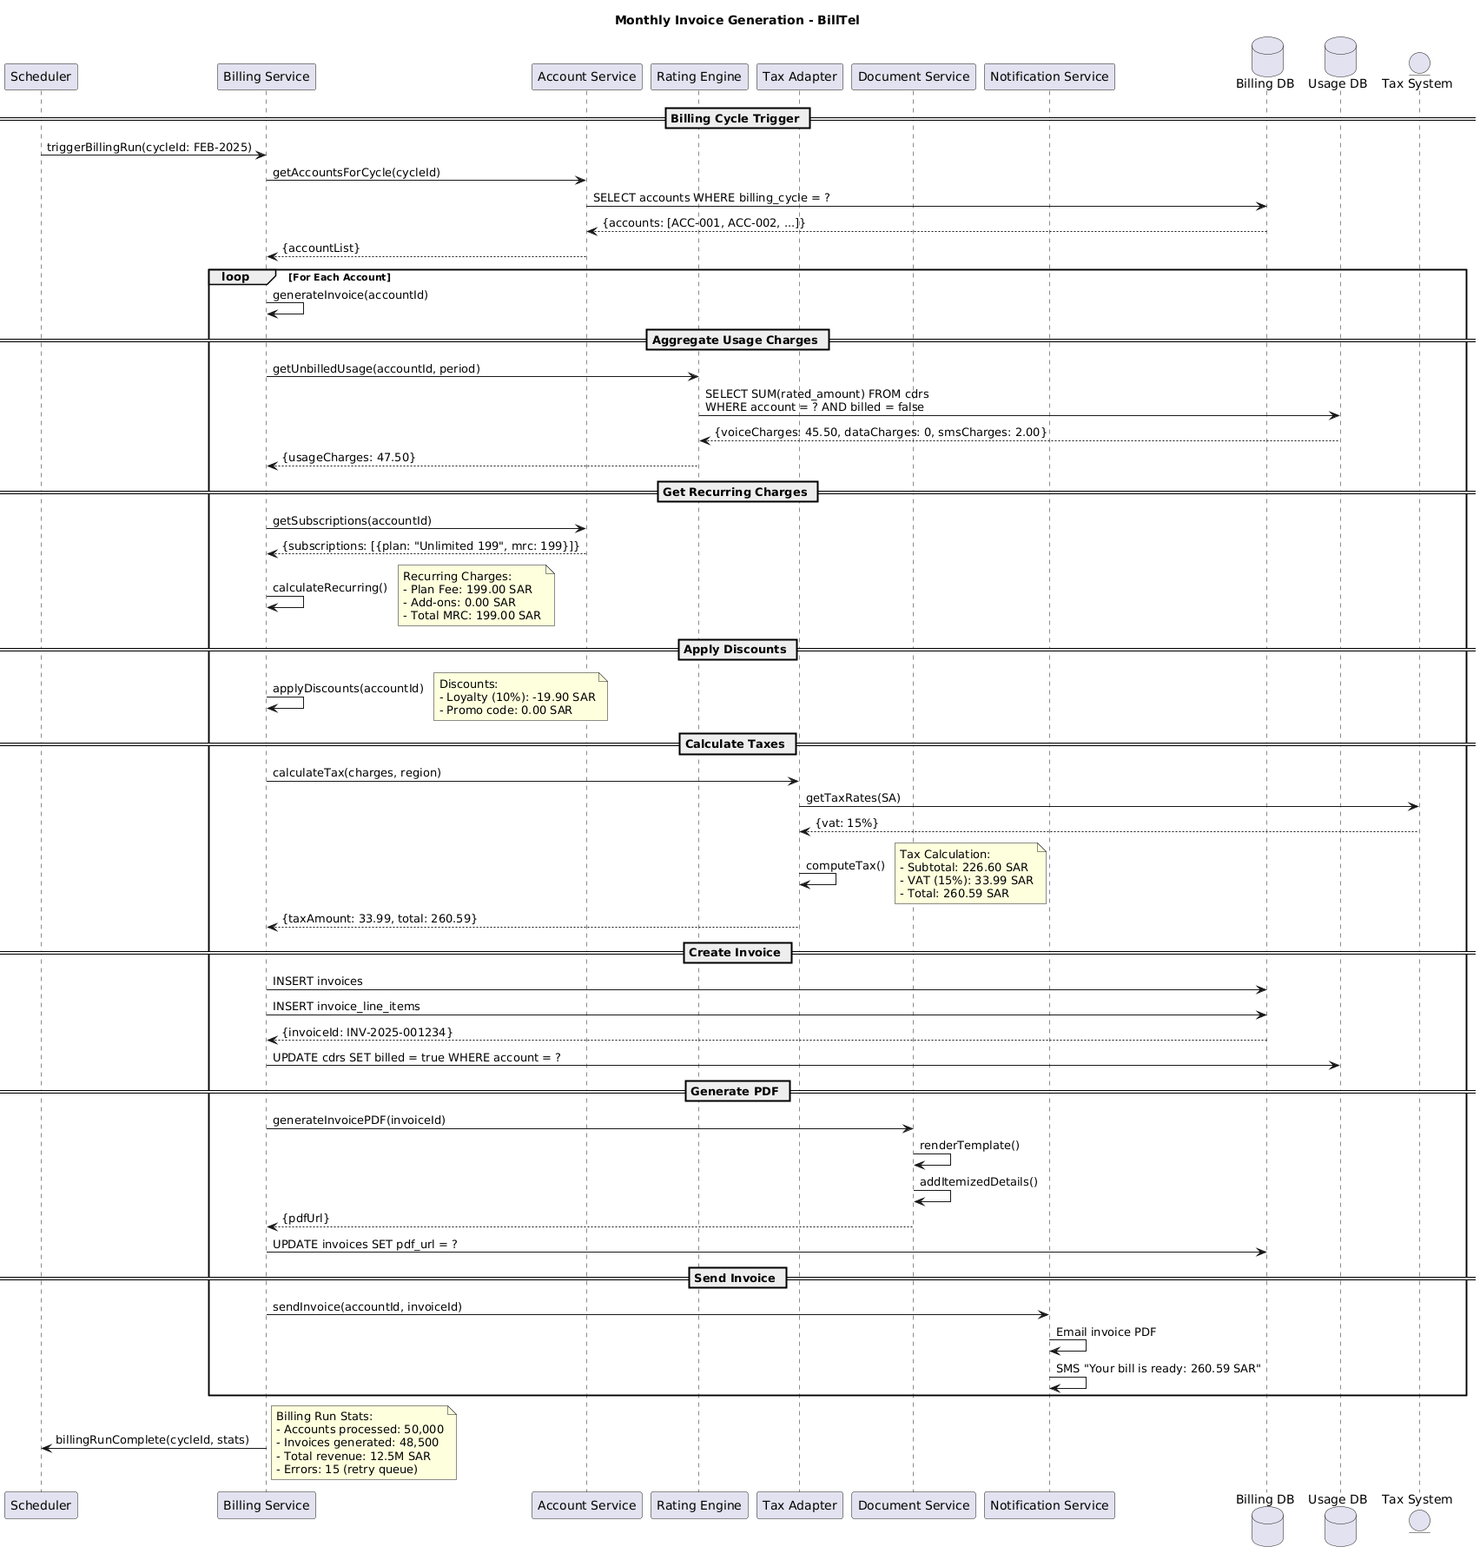

5.2. Flow Description
  - Overview
This flow describes the monthly invoice generation process for BillTel, orchestrated by Scheduler and coordinated through Billing Service. The process covers the retrieval of eligible accounts, aggregation of usage and recurring charges, application of discounts, tax calculation, invoice creation, document generation, and customer notification. The flow repeats these steps for each account in the billing cycle, ensuring that all relevant charges and communications are handled in a consistent and automated manner.
  - Process Flow
Billing Cycle Trigger
Scheduler initiates the process by sending a trigger to Billing Service to start the billing run for the specified cycle (cycleId: FEB-2025). Billing Service requests the list of accounts eligible for this billing cycle from Account Service. Account Service queries Billing DB to select accounts where the billing cycle matches the requested period. Billing DB returns the list of accounts, which Account Service then provides to Billing Service.
Per-Account Invoice Generation
For each account in the returned list, the following sequence is executed:
Billing Service internally generates the invoice for the current account.
SUB### Aggregate Usage Charges
Billing Service requests unbilled usage data for the account and period from Rating Engine. Rating Engine queries Usage DB to sum the rated amounts for call detail records where the account matches and the records are not yet billed. Usage DB returns the aggregated charges, including voice, data, and SMS charges. Rating Engine responds to Billing Service with the total usage charges.
SUB### Get Recurring Charges
Billing Service requests subscription details for the account from Account Service. Account Service returns the list of subscriptions, including plan and monthly recurring charges. Billing Service internally calculates the recurring charges.
Note: Recurring Charges:
- Plan Fee: 199.00 SAR
- Add-ons: 0.00 SAR
- Total MRC: 199.00 SAR
SUB### Apply Discounts
Billing Service internally applies discounts for the account.
Note: Discounts:
- Loyalty (10%): -19.90 SAR
- Promo code: 0.00 SAR
SUB### Calculate Taxes
Billing Service requests tax calculation from Tax Adapter, providing the charges and region. Tax Adapter queries Tax System for the applicable tax rates for the region. Tax System returns the VAT rate. Tax Adapter internally computes the tax amounts.
Note: Tax Calculation:
- Subtotal: 226.60 SAR
- VAT (15%): 33.99 SAR
- Total: 260.59 SAR
Tax Adapter returns the calculated tax amount and total to Billing Service.
SUB### Create Invoice
Billing Service inserts a new invoice record into Billing DB. Billing Service also inserts the associated invoice line items into Billing DB. Billing DB returns the generated invoice ID to Billing Service. Billing Service updates Usage DB to mark the relevant CDRs as billed for the account.
SUB### Generate PDF
Billing Service requests Document Service to generate a PDF version of the invoice, providing the invoice ID. Document Service internally renders the invoice template. Document Service internally adds itemized details to the PDF. Document Service returns the PDF URL to Billing Service. Billing Service updates Billing DB to store the PDF URL in the invoice record.
SUB### Send Invoice
Billing Service instructs Notification Service to send the invoice to the customer, providing the account ID and invoice ID. Notification Service internally sends the invoice PDF via email. Notification Service internally sends an SMS to the customer with the message "Your bill is ready: 260.59 SAR".
Billing Run Completion
After processing all accounts, Billing Service notifies Scheduler that the billing run is complete, including statistics for the cycle.
Note: Billing Run Stats:
- Accounts processed: 50,000
- Invoices generated: 48,500
- Total revenue: 12.5M SAR
- Errors: 15 (retry queue)
  - Self-Interactions
Billing Service internally generates the invoice for the current account.
Billing Service internally calculates the recurring charges.
Billing Service internally applies discounts for the account.
Tax Adapter internally computes the tax amounts.
Document Service internally renders the invoice template.
Document Service internally adds itemized details to the PDF.
Notification Service internally sends the invoice PDF via email.
Notification Service internally sends an SMS to the customer with the message "Your bill is ready: 260.59 SAR".

5.3. State Machine Diagram
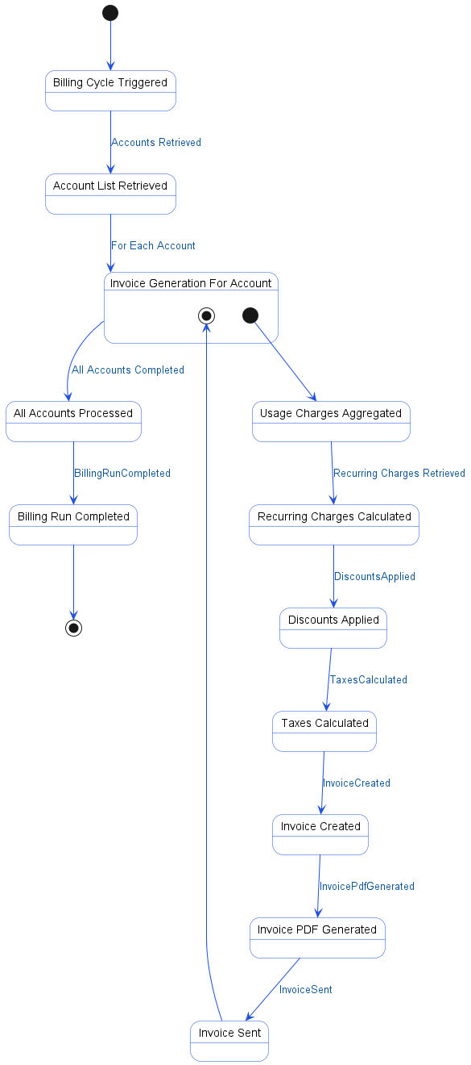

5.4. APIs Contract Agreement
# | Source | Destination | API | Protocol | Request Parameters | Response Parameters
1 | Scheduler | Billing Service | triggerBillingRun | REST | cycleId: FEB-2025
2 | Billing Service | Account Service | getAccountsForCycle | REST | cycleId | {accountList}
3 | Account Service | Billing DB | SELECT accounts WHERE billing_cycle = ? | JDBC |  | {accounts: [ACC-001, ACC-002, ...]}
4 | Billing Service | Rating Engine | getUnbilledUsage | REST | accountId, period | {usageCharges: 47.50}
5 | Rating Engine | Usage DB | SELECT SUM | JDBC | rated_amount | {voiceCharges: 45.50, dataCharges: 0, smsCharges: 2.00}
6 | Billing Service | Account Service | getSubscriptions | REST | accountId | {subscriptions: [{plan: "Unlimited 199", mrc: 199}]}
7 | Billing Service | Tax Adapter | calculateTax | REST | charges, region | {taxAmount: 33.99, total: 260.59}
8 | Tax Adapter | Tax System | getTaxRates | REST | SA | {vat: 15%}
9 | Billing Service | Billing DB | INSERT invoices | JDBC |  | {invoiceId: INV-2025-001234}
10 | Billing Service | Billing DB | INSERT invoice_line_items | JDBC
11 | Billing Service | Usage DB | UPDATE cdrs SET billed = true WHERE account = ? | JDBC
12 | Billing Service | Document Service | generateInvoicePDF | REST | invoiceId | {pdfUrl}
13 | Billing Service | Billing DB | UPDATE invoices SET pdf_url = ? | JDBC
14 | Billing Service | Notification Service | sendInvoice | REST | accountId, invoiceId
15 | Billing Service | Scheduler | billingRunComplete | REST | cycleId, stats
[*] Indicates that the data element is optional

5.5. Error Handling
# | Source | Destination | Scenario | Handling
1 | Billing Service | Account Service | getAccountsForCycle  Timeout while retrieving accounts for billing cycle | Retry up to 3 times with exponential backoff; Log error with correlation ID for traceability; Return error code to upstream caller; Notify operations team via alert if repeated
2 | Billing Service | Account Service | getAccountsForCycle  Account Service unavailable during billing cycle retrieval | Retry up to 3 times with exponential backoff; Log error with correlation ID for traceability; Activate circuit breaker, use fallback response; Notify operations team via alert if repeated
3 | Billing Service | Account Service | getAccountsForCycle  No accounts found for billing cycle | Log error with correlation ID for traceability; Return error code to upstream caller
4 | Billing Service | Rating Engine | getUnbilledUsage  Timeout while retrieving unbilled usage | Retry up to 3 times with exponential backoff; Log error with correlation ID for traceability; Return error code to upstream caller; Notify operations team via alert if repeated
5 | Billing Service | Rating Engine | getUnbilledUsage  Rating Engine unavailable during unbilled usage retrieval | Retry up to 3 times with exponential backoff; Log error with correlation ID for traceability; Activate circuit breaker, use fallback response; Notify operations team via alert if repeated
6 | Billing Service | Rating Engine | getUnbilledUsage  No unbilled usage found for account | Log error with correlation ID for traceability; Return error code to upstream caller
7 | Billing Service | Account Service | getSubscriptions  Timeout while retrieving subscriptions | Retry up to 3 times with exponential backoff; Log error with correlation ID for traceability; Return error code to upstream caller; Notify operations team via alert if repeated
8 | Billing Service | Account Service | getSubscriptions  Account Service unavailable during subscription retrieval | Retry up to 3 times with exponential backoff; Log error with correlation ID for traceability; Activate circuit breaker, use fallback response; Notify operations team via alert if repeated
9 | Billing Service | Account Service | getSubscriptions  No subscriptions found for account | Log error with correlation ID for traceability; Return error code to upstream caller
10 | Billing Service | Tax Adapter | calculateTax  Timeout while calculating tax | Retry up to 3 times with exponential backoff; Log error with correlation ID for traceability; Return error code to upstream caller; Notify operations team via alert if repeated
11 | Billing Service | Tax Adapter | calculateTax  Tax Adapter unavailable during tax calculation | Retry up to 3 times with exponential backoff; Log error with correlation ID for traceability; Activate circuit breaker, use fallback response; Notify operations team via alert if repeated
12 | Billing Service | Tax Adapter | calculateTax  No tax rates found for region | Log error with correlation ID for traceability; Return error code to upstream caller
13 | Billing Service | Document Service | generateInvoicePDF  Timeout while generating invoice PDF | Retry up to 3 times with exponential backoff; Log error with correlation ID for traceability; Return error code to upstream caller; Notify operations team via alert if repeated
14 | Billing Service | Document Service | generateInvoicePDF  Document Service unavailable during PDF generation | Retry up to 3 times with exponential backoff; Log error with correlation ID for traceability; Activate circuit breaker, use fallback response; Notify operations team via alert if repeated
15 | Billing Service | Notification Service | sendInvoice  Timeout while sending invoice notification | Retry up to 3 times with exponential backoff; Log error with correlation ID for traceability; Queue request for asynchronous retry; Notify operations team via alert if repeated
16 | Billing Service | Notification Service | sendInvoice  Notification Service unavailable during invoice notification | Retry up to 3 times with exponential backoff; Log error with correlation ID for traceability; Queue request for asynchronous retry; Notify operations team via alert if repeated

6. Appendix

6.1. Real-Time Usage Rating and Charging Data Elements
# | Service Name | Data Element | Description
1 | Send CDR (voice call ended) (Request) | Caller | Calling party's phone number (MSISDN)
2 | Send CDR (voice call ended) (Request) | Called | Called party's phone number (MSISDN)
3 | Send CDR (voice call ended) (Request) | Start | Call start time
4 | Send CDR (voice call ended) (Request) | Duration | Call duration in seconds
5 | Send CDR (voice call ended) (Request) | Type | Call type (e.g., Mobile Originated)
6 | publish(RAW_CDR) (Request) | RAW_CDR | Raw Call Detail Record data
7 | consume(RAW_CDR) (Request) | RAW_CDR | Raw Call Detail Record data
8 | INSERT cdr_records (Request) | cdr_records | Call Detail Record entries to be stored
9 | publish(PROCESSED_CDR) (Request) | PROCESSED_CDR | Processed Call Detail Record data
10 | consume(PROCESSED_CDR) (Request) | PROCESSED_CDR | Processed Call Detail Record data
11 | getSubscription (Request) | msisdn | Mobile subscriber's phone number
12 | GET subscription:966501234567 (Request) | subscription | Subscription data for the given MSISDN
13 | GET subscription:966501234567 (Response) | subscriptionId | Unique identifier for the subscription
14 | GET subscription:966501234567 (Response) | planId | Identifier for the subscribed pricing plan
15 | GET subscription:966501234567 (Response) | accountType | Type of account (e.g., POSTPAID)
16 | getPricingPlan (Request) | planId | Identifier for the pricing plan
17 | getPricingPlan (Response) | plan | Name of the pricing plan
18 | getPricingPlan (Response) | rates | List of rate definitions for the plan
19 | updateAllowance (Request) | subscriptionId | Unique identifier for the subscription
20 | updateAllowance (Request) | -3min | Minutes to deduct from allowance
21 | DECRBY allowance:voice 3 (Request) | allowance:voice | Voice allowance for the subscription
22 | DECRBY allowance:voice 3 (Request) | 3 | Number of minutes to decrement
23 | DECRBY allowance:voice 3 (Response) | remaining | Remaining voice allowance after deduction
24 | UPDATE cdr SET rated_amount = 0 (Request) | rated_amount | Amount charged for the call after rating
25 | publish(RATED_CDR, amount: 0) (Request) | RATED_CDR | Rated Call Detail Record data
26 | publish(RATED_CDR, amount: 0) (Request) | amount | Amount charged for the rated call
27 | calculateCharge (Request) | overage | Overage call duration exceeding free allowance
28 | applyCharge (Request) | subscriptionId | Unique identifier for the subscription
29 | applyCharge (Request) | 1.50 | Amount to be charged for overage
30 | addToUnbilled (Request) | subscriptionId | Unique identifier for the subscription
31 | addToUnbilled (Request) | 1.50 | Amount to add to unbilled charges
32 | INCRBYFLOAT unbilled:SUB001 1.50 (Request) | unbilled:SUB001 | Unbilled charges for the subscription
33 | INCRBYFLOAT unbilled:SUB001 1.50 (Request) | 1.50 | Amount to increment unbilled charges
34 | checkBalance (Request) | subscriptionId | Unique identifier for the subscription
35 | GET balance:SUB001 (Request) | balance:SUB001 | Balance for the subscription
36 | GET balance:SUB001 (Response) | balance | Current balance value for the subscription
37 | deductBalance (Request) | subscriptionId | Unique identifier for the subscription
38 | deductBalance (Request) | 1.50 | Amount to deduct from balance
39 | DECRBY balance:SUB001 1.50 (Request) | balance:SUB001 | Balance for the subscription
40 | DECRBY balance:SUB001 1.50 (Request) | 1.50 | Amount to decrement from balance
41 | DECRBY balance:SUB001 1.50 (Response) | newBalance | New balance after deduction
42 | publish(RATED_CDR, amount: 0) (Response) | charged | Indicates that the charge was applied
43 | publish(RATED_CDR, amount: 0) (Response) | balance | Current balance after charging
44 | publish(RATED_CDR, amount: 0) (Response) | charged | Indicates that the charge was applied
45 | publish(RATED_CDR, amount: 0) (Response) | charged: partial | Indicates partial charge due to insufficient balance
46 | sendLowBalanceAlert (Request) | msisdn | Mobile subscriber's phone number
47 | checkThresholds (Request) | balance | Current balance to check against notification thresholds

6.2. Monthly Invoice Generation Data Elements
# | Service Name | Data Element | Description
1 | triggerBillingRun (Request) | cycleId | Billing cycle identifier (e.g., FEB-2025)
2 | getAccountsForCycle (Request) | cycleId | Billing cycle identifier for account selection
3 | getAccountsForCycle (Response) | accountList | List of account identifiers for the billing cycle
4 | generateInvoice (Request) | accountId | Unique identifier for the customer account
5 | getUnbilledUsage (Request) | accountId | Unique identifier for the customer account
6 | getUnbilledUsage (Request) | period | Usage period for which charges are calculated
7 | getUnbilledUsage (Response) | usageCharges | Total unbilled usage charges for the account
8 | getSubscriptions (Request) | accountId | Unique identifier for the customer account
9 | getSubscriptions (Response) | subscriptions | List of active subscriptions for the account
10 | getSubscriptions (Response) | plan | Name of the subscribed plan
11 | getSubscriptions (Response) | mrc | Monthly recurring charge for the subscription plan
12 | applyDiscounts (Request) | accountId | Unique identifier for the customer account
13 | calculateTax (Request) | charges | Total charges before tax calculation
14 | calculateTax (Request) | region | Geographic region for tax calculation
15 | calculateTax (Response) | taxAmount | Calculated tax amount for the invoice
16 | calculateTax (Response) | total | Total invoice amount after tax
17 | generateInvoicePDF (Request) | invoiceId | Unique identifier for the generated invoice
18 | generateInvoicePDF (Response) | pdfUrl | URL to access the generated invoice PDF
19 | sendInvoice (Request) | accountId | Unique identifier for the customer account
20 | sendInvoice (Request) | invoiceId | Unique identifier for the generated invoice
21 | billingRunComplete (Request) | cycleId | Billing cycle identifier for run completion
22 | billingRunComplete (Request) | stats | Summary statistics for the billing run

6.3. Solution Architecture Reference Documents
# | Name | File
1 | BRD | Refer to Latest BRD Attached to JIRA Ticket

